Django Guidelines

Writing an extra field for Serializer based on a query:

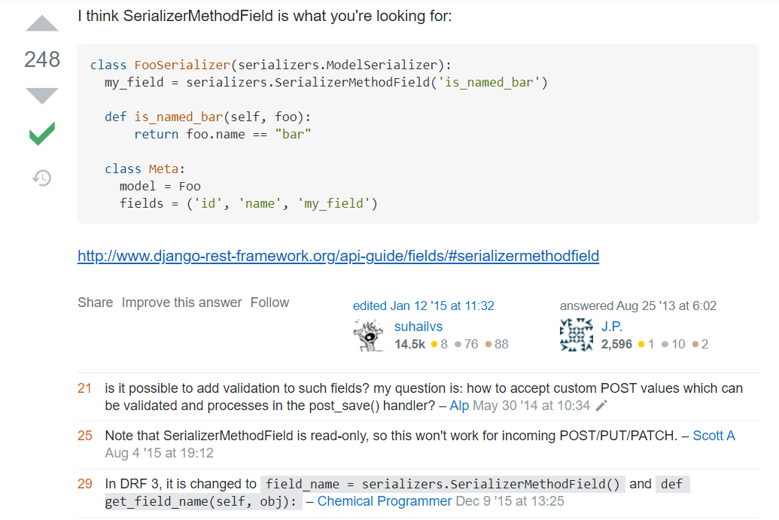

Field change name

